Name : Prem Vinod Bansod
Roll No : 41310
Assignment No : 02 (ML)

Title: To implement Decision Tree Classifier.

Problem Statement: A dataset collected in a cosmetics shop showing details of customers and whether they responded to a special offer to buy a new lipstick is shown in table below. Use this dataset to build a decision tree, with Buys as the target variable, to help in buying lipsticks in the future. Find the root node of decision tree. According to the decision tree you have made from previous training data set, what is the decision for the test data: [Age < 21, Income = Low, Gender = Female, Marital Status = Married]?

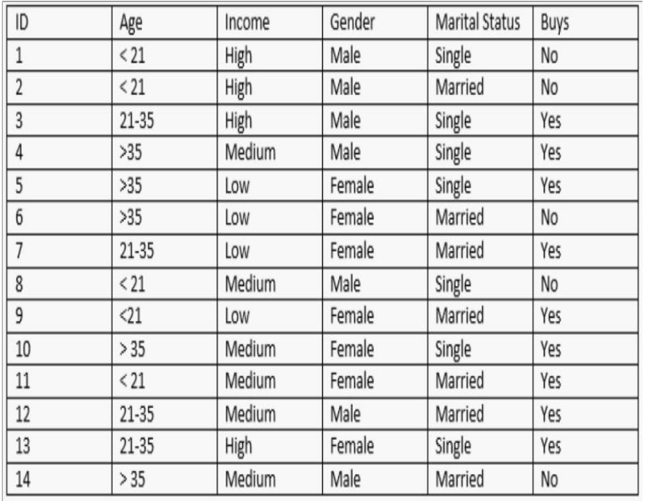
Objective:
- The Basic Concepts of Decision Tree Classifier.
- Implementation logic of Decision Tree Classifier.

Theory:
Introduction:
A decision tree is a flowchart-like structure in which internal node represents a "test" on an attribute (e.g. whether a coin flip comes up heads or tails), each branch represents the outcome of the test and each leaf node represents a class label (decision taken after computing all attributes). The paths from root to leaf represent classification rules. Decision trees are diagrams that attempt to display the range of possible outcomes and subsequent
Decisions made after an initial decision. For example, your original decision might be whether to attend college, and the tree might attempt to show how much time would be spent doing different activities and your earning power based on your decision. There are several notable pros and cons to using decision trees.
In decision analysis, a decision tree and the closely related influence diagram are used as a visual and analytical decision support tool, where the expected values (or expected utility) of competing alternatives are calculated.

A decision tree consists of 3 types of nodes:
1. Decision nodes - commonly represented by squares
2. Chance nodes - represented by circles
3. End nodes - represented by triangles

Decision trees are commonly used in operations research, specifically in decision analysis, to help identify a strategy most likely to reach a goal. If in practice decisions have to be taken online with no recall under incomplete knowledge, a decision tree should be paralleled by a probability model as a best choice model or online selection model algorithm. Another use of decision trees is as a descriptive means for calculating conditional probabilities.
Decision trees, influence diagrams, utility functions, and other decision analysis tools and methods are taught to undergraduate students in schools of business, health economics, and public health, and are examples of operations research or management science methods.

ALGORITHM USED:
- In decision tree learning, ID3 (Iterative Dichotomiser 3) is an algorithm invented by Ross Quinlan used to generate a decision tree from a dataset.
- The ID3 algorithm begins with the original set as the root node. On each iteration of the algorithm, it iterates through every unused attribute of the set and calculates the entropy (or information gain) of that attribute. It then selects the attribute which has the smallest entropy (or largest information gain) value. The set is then split by the selected attribute (e.g. age < 50, 50 <= age < 100, age >= 100) to produce subsets of the data. The algorithm continues to Recurse on each subset, considering only attributes never selected before.
- Recursion on a subset may stop in one of these cases:
- Every element in the subset belongs to the same class (+ or -), then the node is turned into a leaf and labelled with the class of the examples
- There are no more attributes to be selected, but the examples still do not belong to the same class (some are + and some are -), then the node is turned into a leaf and labelled with the most common class of the examples in the subset
- There are no examples in the subset, this happens when no example in the parent set was found to
- be matching a specific value of the selected attribute, for example if there was no example with age
- >= 100. Then a leaf is created, and labelled with the most common class of the examples in the parent set.
- Throughout the algorithm, the decision tree is constructed with each non-terminal node representing the
- selected attribute on which the data was split, and terminal nodes representing the class label of the final subset of this branch.

Summary:
- Calculate the entropy of every attribute using the data set
- Split the set into subsets using the attribute for which entropy is minimum (or, equivalently, information gain is maximum)
- Make a decision tree node containing that attribute.
- Recurse on subsets using remaining attributes

Decision trees offer advantages over other methods of analyzing alternatives.
They are:
Graphic 
You can represent decision alternatives, possible outcomes, and chance events schematically. The visual approach is particularly helpful in comprehending sequential decisions and outcome dependencies.
Efficient 
You can quickly express complex alternatives clearly. You can easily modify a decision tree as new information becomes available. Set up a decision tree to compare how changing input values affect various decision alternatives. Standard decision tree notation is easy to adopt.
Revealing 
You can compare competing alternatives-even without complete information-in terms of risk and probable value. The Expected Value (EV) term combines relative investment costs, anticipated payoffs, and uncertainties into a single numerical value. The EV reveals the overall merits of competing alternatives. Complementary You can use decision trees in conjunction with other project management tools. For example, the decision tree method can help evaluate project schedules.

Decision trees are self-explanatory and when compacted they are also easy to follow. In other words if the decision trees has a reasonable number of leaves, it can be grasped by non-professional users. Furthermore decision trees can be converted to a set of rules. Thus, this representation is considered as comprehensible.

- Decision trees can handle both nominal and numerical attributes. 
- Decision trees representation is rich enough to represent any discrete-value classifier. 
- Decision trees are capable of handling datasets that may have errors. 
- Decision trees are capable of handling datasets that may have missing values. 
- Decision trees are considered to be a nonparametric method. This means that decision trees have no assumptions about the space distribution and the classifier structure. 
- On the other hand, decision trees have disadvantages such as:
- Most of the algorithms (like ID3 and C4.5) require that the target attribute will have only discrete values. 
•
As decision trees use the ―divide and conquer ‖ method, they tend to perform well if a few highly relevant attributes exist, but less so if many complex interactions are present. One of the reasons for this is that other classifiers can compactly describe a classifier that would be very challenging to represent using a decision tree. 
• The greedy characteristic of decision trees leads to another disadvantage that should be pointed out. This is its over-sensitivity to the training set, to irrelevant attributes and to noise. 

Conclusion: We have studied the Decision tree classifier and also implemented successfully.

